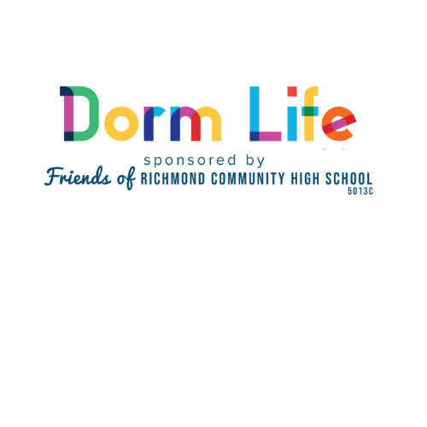

DORM SHOPPING LIST – READY FOR COLLEGE

Purchased items will be provided to Richmond Public School graduates attending college in the fall. Many students beat the odds to get into college and earn the scholarships they need but then face the difficulty of funding the basics they need to start the year. With the requirement of purchasing a computer on top of the basics listed here it can run families up to $1000 just to show up on day one. For many families that covers 3 months of groceries. Items will be distributed through and the donations recorded by the nonprofit, Friends of RCHS, EIN 81-3292324.
- Comforter and/or quilts Twin XL – Solid colors are best – White, Blue, Black, Grey..
- Bed sheets and pillow cases (Suggested Size: Twin XL)
- Bed Pillows
- Mattress pad
- Towels: 2 sets of bath and washcloth is best
- Shower Caddy
- First Aid kit
- Clip on or small fan
- Laundry bag or basket
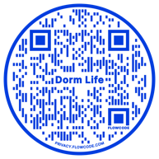
- Hangers
- Large Duffel Bag
- Small book case or storage under bed
- Sticky wall mounts and removable adhesive hooks.
- Rug – 5 x7
- Desk lamp
- Trashcan
- Bed risers
- Over the door storage hanger
- Bulletin Board or picture mounting board
- Dry-Erase Markers
- Surge protector or multi plug charger for USB and regular plugs
- A sturdy backpack or book bag for everyday use
- Desk organizers
- General desk supplies and school supplies
- Grooming Kit
- Laundry items
- Dorm Refrigerator (optional 3.2 cubic ft or less)
- Personalize it with an item from the college they will attend with a banner, T-shirt, Sweatshirt, water tumbler…
Items can be dropped off or you can arrange for them to be picked up by calling (804) 475-6134
In the City:
Richmond Community High School
201 East Brookland Park Blvd
Richmond, VA 23222
Hours: 9 am – 4 pm M-F
In West End:
C/O Alison Owens
1708 Windingridge Court
Henrico, VA 23238
Anytime
USE THIS ADDRESS IF ORDERING ITEMS ONLINE

